BUas Research Ethics Review Application Form
v1.1

N.B. The assessment by the BUas Research Ethics Review Board will be conducted in compliance with the Standards for Good Research Practices, from: Netherlands Code of Conduct for Research Integrity (2018). An overview of these standards is included to this form as an appendix, for the applicant’s convenient reference.

A - GENERAL INFORMATION
REVIEW APPLICATION FORM – registration code: | N.B. WILL BE ENTERED BY REVIEW BOARD  REGISTRATION CODE: < Project # (YY/MM + order of receipt)-REV (review application form)-serial# in document sequence-IP (in progress) or CC (case closed) e.g. 2101-01-REV-01-IP>
REQUEST FOR: | (NON-BINDING) ADVICE | CRITICAL REVIEW / ASSESSMENT  <mark bold / underlined if selected>
Date of Review Application Submission: | 23 February 2026

B – APPLICATION PACKAGE
List of documents included with the application (i.e. the input for the committee’s advice / assessment) | 1. This completed BUas Research Ethics Review Application Form  2. FAIR Checklist (O1_FAIR_Checklist.md)  3. Privacy and GDPR Compliance Checklist (O1_Privacy_GDPR_Checklist.md)  4. Data Storage, Sharing and Protection Protocol (O1_Data_Storage_Protocol.md)  5. Ethical Considerations and Decisions (O1_Ethical_Considerations.md)  6. Research Proposal (O1_research_proposal.pdf — to be submitted Week 3)

C - PERSONAL INFORMATION APPLICANT
Name of applicant (lead researcher): | Wojciechowicz, Aron
e-Mail address: | 245205@buas.nl
BUas Department (Research Group): | Data Science & AI, Year 2 Block C
External parties involved (individuals or groups from other universities, organizations): | Research Cohort Members: Aron Wojciechowicz, Danil Sysenko, Filipp Lotsmanov, Alex Krasnoshtanov, Maksym Steshkin (all BUas ADS&AI students)
Application approved by professor or research group leader (if applicant does not have this role him-/herself): | Peiman Barnaghi, [date] (pending mentor approval)

D - RESEARCH PROJECT DESCRIPTION
Name of Research Project: | Real-Time Audio-Visual Deepfake Generation: Quality-Latency Tradeoff Analysis
Projected Project Duration: | February 2026 - April 2026 (8 weeks, Block C)
Research Project Rationale  (i.e. what is the intended goal, the ‘point’ of the research project? This brief description helps to establish the interpretation frame for the review board) | This research quantifies the quality-latency tradeoff in real-time deepfake generation systems. Real-time deepfake systems must balance computational efficiency (low latency) with output quality (visual fidelity and audio-visual synchronization). This tradeoff is not well-quantified in existing literature. The study systematically compares offline and real-time generation approaches across multiple quality dimensions, including visual fidelity, audio-visual synchronization, and temporal consistency. The individual sub-question investigates how Post-Training Quantization (FP32 vs INT8) impacts the tradeoff between inference latency, memory footprint, and model accuracy.
Brief Overview of Methods  (i.e. what will be done with/to research project participants / respondents / informants): | This is a computational research study using publicly available datasets (FakeAVCeleb, CC BY 4.0 license). No human participants are directly involved in the primary computational experiments. One team member (Danil Sysenko) will conduct a supplementary Mean Opinion Score (MOS) perceptual study involving 20-30 adult volunteer participants who will rate video quality on a 1-5 scale. MOS participants will view pre-generated deepfake videos and provide anonymous ratings. No personal data is collected beyond anonymous quality ratings. Participants can withdraw at any time without consequence. All deepfake outputs are generated from the FakeAVCeleb dataset of celebrity videos consented for research use. No new identity manipulation of real persons is performed. All generated outputs remain on secured university servers and are deleted after the project.

E - ADVICE AND ASSESSMENT ELEMENTS
(Approval by the Research Ethics Review Board is conditional on the accuracy of the information presented below. The overarching assessment framework of values and standards is in compliance with the 2018 Netherlands Code of Conduct for Research Integrity – see appendix for the core standards)

E0 – Preliminary Risk Assessment
(this preliminary check of elements E0.1, E0.2a and E0.2b. matches the questions (1), (2a) and (2b) of the RESEARCH ETHICS SELF-ASSESSMENT FORM. These elements E0.1, E0.2a and E0.2b establish a first risk assessment of the proposed research project, to help classify the application in a LOW, MEDIUM or HIGH risk category. After the Preliminary Risk Assessment, assessment elements E1-E4 below will address the four main research ethics assessment criteria)

E0.1 – Preliminary Risk Assessment: Special Rules Regarding Medical Research
E0.1a - Does your research involve medical scientific research? | ☐YES  ☒ NO | If E0.1a = YES, explain: How?
E0.1b - Does your research involve medicinal products? | ☐YES  ☒ NO | If E0.1b = YES, explain: How?
E0.1c - Does your research involve collecting tissue samples, blood, etc.? | ☐YES  ☒ NO | If E0.1c = YES, explain: How?
E0.1d - Does your research involve situations in which participants are subject to specific procedures or are required to follow rules of behaviour? | ☐YES  ☒ NO | If E0.1d = YES, explain: How?
 | ☐ YES at least once in E0.1 Research proposals subject to the WMO (Dutch Medical Research Involving Human Subjects Act) require assessment by a specially accredited medical ethics review board. If you wish to conduct this kind of research and seek medical ethics approval, please contact the BUas Research Ethics Review Board via <...@...>.
 | ☐ NO on all questions in E0.1 continue with E0.2
E0.2 – Preliminary Risk Assessment: Participants
E0.2a – Participant Consent Capacity
E0.2a1 - Does your research involve individuals lacking capacity or agency to consent, namely children under 12? | ☐YES  ☒ NO |  | If E0.2a1 = YES, explain: How? And: Why?
E0.2a2 - Does your research involve individuals lacking capacity or agency to consent, namely children aged 12-16? | ☐YES  ☒ NO |  | If E0.2a2 = YES, explain: How? And: Why?
E0.2a3 - Does your research involve individuals lacking capacity or agency to consent, namely participants unable to give consent, e.g. in case of mental or legal incapacity? | ☐☐ YES ☒ NO☐ |  | If E0.2a3 = YES, explain: How? And: Why?
E0.2b – Treatment of Participants
E0.2b1 - Does your research involve situations in which participants might experience physical or psychological stress? Physical stress might include, but is not limited to, pain or discomfort. Psychological stress might include, but is not limited to, interview or survey questions about painful or traumatic experiences. | ☐YES  ☒ NO |  | If E0.2b1 = YES, explain: How? And: Why?
E0.2b2 - Does your research involve the collection of sensitive data which can endanger the participant’s privacy? This might include but is not limited to data about the participant’s religion, political affiliation, criminal history or sex life. | ☒ YES ☐ NO |  | The FakeAVCeleb dataset contains face and voice recordings of public figures (celebrities). This constitutes biometric data under GDPR Article 9. However, the dataset is publicly available under CC BY 4.0 license for research purposes, and subjects consented to its creation. No new biometric data is collected. All processing occurs on secured university servers. Generated outputs are used solely for quality metric evaluation and are deleted post-project.
E0.2b3 - Does your research involve procedures or situations which might raise doubt in any other way whether proper rules of research conduct are followed? Answer ‘YES’ if any of the following are in doubt: implementation of a secure research protocol detailing who / what / when / where / why; only necessary data is collected in a legal/rightful way; a careful informed consent procedure; proper safeguards against illegitimate access to and/or modification of the data, defined in a secure data management policy. | ☒ YES ☐ NO |  | Deepfake research has inherent dual-use potential. Our study benchmarks existing publicly available models and does not develop novel generation capabilities. Mitigation measures include: (1) no release of trained models or generation code, (2) all outputs deleted after metric computation, (3) responsible disclosure framework in the research paper, (4) research framed to inform detection and defense strategies. The study advances understanding of deepfake limitations, which benefits defensive research.
☐ YES at least once in E0.2a,b your research probably requires approval from the BUas Research Ethics Review Board. Please do the following two things:
first, under ‘E0 – Preliminary Risk Assessment - OUTCOME’, indicate which category you believe your research project to belong. N.B. based on the information provided in this review application form, the research ethics review board will also categorize the project; this categorization might be different from yours. In the follow-up process, addressing this assessment and any potential divergent analyses can be part of a constructive, solution-focused dialogue.
second, continue with assessment elements E1-4 below, to add more detailed information for the formal research ethics approval process.
 | ☐ NO on all questions your research probably does not require approval from the BUas Research Ethics Review Board. If you are still in doubt and/or wish to request advice from the BUas Research Ethics Review Board, please contact the board via <...@...>.

E0 – Preliminary Risk Assessment - OUTCOME
Risk Assessment:  (based primarily on the following risk categories, as specified in the Review Application Form: involvement of vulnerable and/or underage participants; presence of privacy safeguards; negative effects of test design on participants, environment and/or property) | LOW  <mark bold / underlined if selected> | MEDIUM | HIGH  <mark bold / underlined if selected>

E1 - Informed Consent of Participants
(e.g. does this study involve minors or other vulnerable groups? Are participants instructed properly?)

E1.1 – Will the participants, or (in case of one or more times YES on questions E0.2a1,2,3) their legal parents / guardians / representatives, be informed about the reason for and nature of the research and the manner in which their data is used, in advance and in full? | ☒ YES ☐ NO | MOS study participants will be fully informed before participation. They will receive written information explaining: (1) the research purpose, (2) that videos contain AI-generated content, (3) what they will be asked to do (rate video quality 1-5), (4) that participation is voluntary, (5) that responses are anonymous. For the computational experiments, no human participants are involved.
E1.2 – Will the participants give actively informed / explicit consent to their participation in the research, and the manner in which their data is used? E.g. by signing a clear, truthful and complete consent form, without being placed under duress to comply.  N.B. this applies if participant is over 16 and able to give legal consent. If between 12 and 16: consent by participants PLUS their legal parents / guardians / representatives. If under 12 or unable to give consent due to mental or legal incapacity: consent by their legal parents / guardians / representatives. | ☒ YES ☐ NO | MOS participants will provide written informed consent via a consent form before viewing any videos. The consent form clearly states the voluntary nature of participation and the right to withdraw.
E1.3 – Will it be clear to participants that they can terminate their participation in the research at all times? | ☒ YES ☐ NO | If E1.3 = NO, explain: Why not?
E1.4 – Outside of this research project, are the participants in a subordinate relationship to the researcher? E.g. lecturer vs. students, or manager vs. employees. | ☐YES  ☒ NO | If E1.4 = YES, explain: How?

E2 - Safeguards to Avoid Negative Consequences
(e.g. is there sufficient focus on participant wellbeing, environmental sustainability in methodological design? If there are to be negative consequences, is there a convincing reason for this?)

E2.1 – Will participants be under any risk of harm, damage, danger or stress during the research? Include your answer to question E0.2b1: Does your research involve situations in which participants might experience physical or psychological stress? | ☐ YES ☒ NO | If E2.1 = YES, explain: How? And: also answer E2.4 and E2.5.  If E2.1, E2.2 and E2.3 = NO, mark E2.4 and E2.5 as N/A (not applicable) and continue with E2.6.
E2.2 – Will your research create any risk of harm, damage, danger or stress for any non-participants, animals, the environment, public or private property, or in any other way? | ☐ YES ☒ NO | If E2.2 = YES, explain: How? And: also answer E2.4 and E2.5.  If E2.1, E2.2 and E2.3 = NO, mark E2.4 and E2.5 as N/A (not applicable) and continue with E2.6.
E.2.3 – Will your research create any risk of harm, damage, danger or stress for the researcher or any member of the research team, of for the reputation or property of Breda University of Applied Sciences? | ☒ YES ☐ NO | Deepfake technology poses societal risks including identity fraud, misinformation, and non-consensual media manipulation. Our research benchmarks existing systems rather than creating novel capabilities. Safeguards: (1) no new model development, (2) no release of generation pipelines, (3) all synthetic outputs deleted post-analysis, (4) responsible disclosure in publications, (5) findings framed to support detection research and inform policy.
If E2.1, E2.2 and/or E2.3 = YES:  E2.4 – If there is any risk of harm, damage, danger or stress, is the importance of the research sufficiently great to offset that risk? (proportionality) | ☒ YES ☐ NO | Safeguards are proportional to the risk. The study uses only pre-existing public models and datasets. No novel attack capabilities are created. All outputs are ephemeral (deleted after metric computation). The research contributes to defensive understanding of deepfake limitations.
If E2.1, E2.2 and/or E2.3 = YES:  E2.5 – If there is any risk of harm, damage, danger or stress, can the research design be modified in such a way that said risk is lowered? (subsidiarity) | ☒ YES ☐ NO | MOS study participants are informed that videos contain AI-generated content before viewing. They understand they are evaluating synthetic media quality, not being deceived.
E2.6 – Will participants be rewarded for their participation? | ☐ YES ☒ NO | If E2.6 = YES, explain: How and Why?
E2.7 – Are there any other (potential) benefits to participating in this research for the participants, other than the reward as specified in E2.6? | ☐ YES ☒ NO | If E2.7 = YES, explain: How and Why?

E3 - Integrity in Research Project Management
(e.g. are there conflicts of interest involving participants, researchers and/or financiers?)

E3.1 – Who / what is the source of funding for the research? |  | This research is conducted as part of the BUas Applied Data Science & AI curriculum (Block C). No external funding is involved. Computational resources are provided by BUas (Linux server with NVIDIA L40S GPUs).
E3.2 – Will the funding organization have any control over the methods, execution and/or reporting of the research? | ☐ YES  ☒ NO | If 3.2 = YES, explain: How?
E3.3 – Are there any researchers involved with the research who have connections to any organization or company, in such a way that a conflict of interests (or the impression thereof) might arise? | ☐ YES  ☒ NO | If 3.3 = YES, explain: How? And: What will be done to mitigate that risk?

E4 - Privacy and Data Management
(e.g. availability of sound data management plan)

E4.1 – Is there a Data Management Plan? | ☒ YES ☐ NO | A comprehensive Data Management Plan (O1_dmp.md) is included in the application package. It covers data collection, storage, access control, retention, and deletion procedures.
E4.2 – Will it be possible to link any data to specific participants? E.g. will any of the data NOT be anonymous? | ☐ YES ☒ NO | MOS study responses are collected anonymously. No names, emails, or identifiable information is recorded. Only anonymous numerical ratings (1-5 scale) are stored. The FakeAVCeleb dataset contains celebrity identities but these are already public; no new personal data linkage is created.
If E4.2 = YES:  E4.3 – Will any personal information (name, address, phone number, etc.) be stored? | ☒N/A | If E4.3 = YES, explain: Why?
E4.4 – How will the data be stored? Who will have access to any private and/or non-anonymized data (including but not limited to the raw data)? |  | All research data is stored on BUas-provided Linux servers with restricted access (SSH key authentication). Only the five research cohort members and the assigned mentor have access. The FakeAVCeleb dataset is stored in a dedicated project directory with appropriate permissions. Generated deepfake outputs are stored temporarily for metric computation and deleted after block ends. MOS ratings are stored as anonymized CSV files on the university server. No data is stored on personal devices or cloud services. All project data will be deleted within 30 days of project completion (April 2026), except for anonymized metric results retained for academic reporting.

- APPENDIX: Standards for Good Research Practices, from: Netherlands Code of Conduct for Research Integrity (2018).

APPENDIX: Standards for Good Research Practices,
from: Netherlands Code of Conduct for Research Integrity (2018).

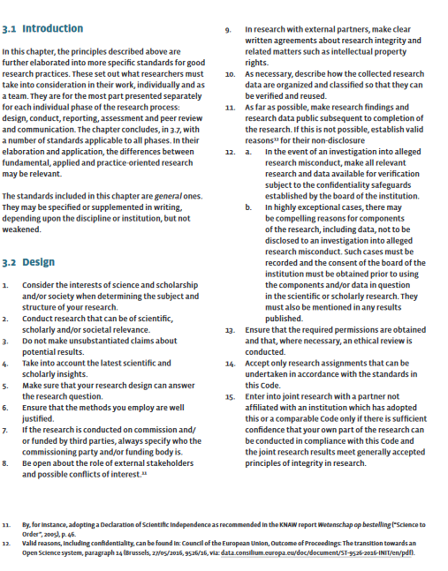

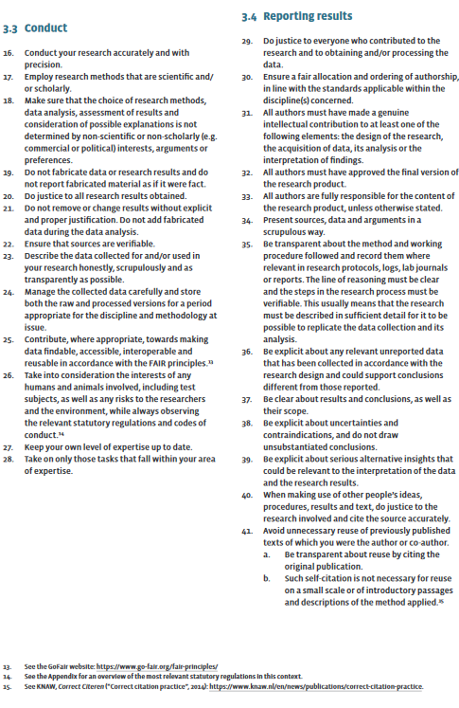

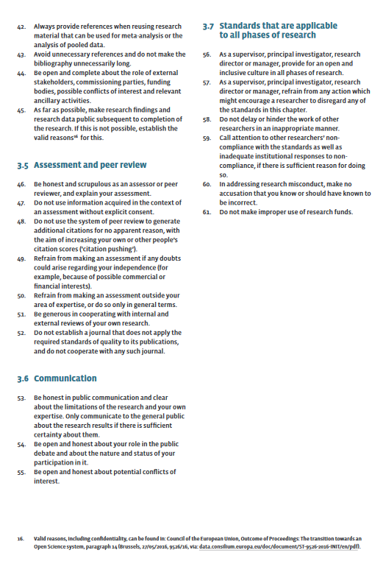

“Medical/scientific research is research which is carried out with the aim of finding answers to a question in the field of illness and health (etiology, pathogenesis, signs/symptoms, diagnosis, prevention, outcome or treatment of illness), by systematically collecting and analysing data. The research is carried out with the intention of contributing to medical knowledge which can also be applied to populations outside of the direct research population.” (from: https://english.ccmo.nl/investigators/legal-framework-for-medical-scientific-research/your-research-is-it-subject-to-the-wmo-or-not)
“In general, research with human subjects is only subject to the WMO if there is an infringement of the physical and/or psychological integrity of the subject. The subject himself/herself must be physically involved in the research for the research to be subject to the WMO. Therefore retrospective research/file research is not subject to the WMO. In that case the data are already available and not collected specifically for a medical-scientific research. The subject does not have to do or abstain from something on behalf of the research. A blood sample being taken from the participant for the purpose of scientific research: this is always subject to the WMO as the participant is subjected to a procedure. If additional blood is taken for the research as part of a planned vene puncture or from an existing line, then the research is also subject to the WMO. Research during which a participant must provide one urine sample once, generally is not subject to the WMO. However, research during which urine samples must be provided over the course of a three-week period does.” (from: https://english.ccmo.nl/investigators/legal-framework-for-medical-scientific-research/your-research-is-it-subject-to-the-wmo-or-not)
For more information on whether your research might be subject to the WMO (the Dutch Medical Research Involving Human Subjects Act), see: https://english.ccmo.nl/investigators/legal-framework-for-medical-scientific-research/your-research-is-it-subject-to-the-wmo-or-not
From 16 years of age, for all mentally and legally competent participants, consent for approved research is only obtained from the participant. For some types of research it may nevertheless be good practice to inform the parents or legal guardian/representatives. IF ANY OF THE CASES AS SPECIFIED ABOVE APPLY, make special note of the consent requirements for when you enter the formal approval process, particularly for ADVICE AND ASSESSMENT ELEMENT E1 - Informed Consent of Participants.
In case of minors under 12 years of age, informed consent is obtained from the parent(s) or legal guardian/ representative(s). It is good practice to also ask the child where possible. N.B. This is all IF the research is deemed appropriate, because in principle, scientific research for this group is severely restricted, and is generally subject to a ‘no, unless’-policy. See also https://english.ccmo.nl/investigators/additional-requirements-for-certain-types-of-research/research-with-subjects-under-the-age-of-16-years
In case of minors between 12 and 16 years of age, informed consent is obtained from both the minor and the parent(s) or legal guardian/representative(s). N.B. This is all IF the research is deemed appropriate, because in principle, scientific research for this group is severely restricted, and is generally subject to a ‘no, unless’-policy. See also https://english.ccmo.nl/investigators/additional-requirements-for-certain-types-of-research/research-with-subjects-under-the-age-of-16-years

